#### SAVEETHA SCHOOL OF ENGINEERING

**SAVEETHA INSTITUTE OF MEDICAL AND TECHNICAL SCIENCES**

**CHENNAI-602105**

**SMARTPHONE APP DEVELOPMENT FOR LOCAL EVENTS**

#### A CAPSTONE PROJECT REPORT

*Submitted in the partial fulfillment for the completion of the course*

**CSA4317-INTERNET PROGRAMMING WITH MOBILE APP INTEGRATION**

**COMPUTER SCIENCE AND ENGINEERING**

**Submitted by**

**CHRISTOPHER E**

**(191911005)**

#### Under the Supervision of

**Ms. L. REETHA**

**NOV 2024**

## DECLARATION

I am Christopher E student of the Computer Science and Engineering,

Saveetha Institute of Medical and Technical Sciences, Saveetha School of Engineering, Chennai, hereby declare that the work presented in this Capstone Project Work entitled smartphone app development for local events is the outcome of our own Bonafide work and is correct to the best of our knowledge and this work has been undertaken taking care of Engineering Ethics.

CHRISTOPHER E (191911005)

Date:

Place:

## CERTIFICATE

This is to certify that the project entitled **“**smartphone app development for local events**”** submitted by

Christopher E has been carried out under my supervision. The project has been submitted as per the requirements in the current semester of B.E. Computer Science and Engineering.

Supervisor

Ms. L. Reetha

# Table of Contents

| **S.NO** | **TOPICS** | **PAGE NO.** |
| --- | --- | --- |
| 1 | **Abstract** | **1-2** |
| 2 | **Introduction** | **3-4** |
| 3 | **Project Description** | **4-5** |
| 4 | **Problem Description** | **5-6** |
| 5 | **Tool Description** | **7-8** |
| 6 | **Operations** | **9-10** |
| 7 | **Module Description** | **10-13** |
| 8 | **Implementation** | **13-17** |
| 9 | **Result** | **17-18** |
| 10 | **Conclusion & References** | **19-23** |

**Aim**

To provide a simple, secure smartphone app for local events hosted. It enhances convenience and more accessibility to the users involving different features.

**Abstract**

A smartphone app designed for local events would serve as a centralized platform to readily inform residents about nearby community gatherings, festivals, markets, workshops, and other happenings, providing features like event listings with detailed information, interactive maps, personalized notifications, ticket purchasing capabilities, and community engagement tools, all accessible conveniently on their mobile devices, thereby boosting local participation and awareness of community events.

**Keywords**

"local events app", "community calendar", "nearby events", "event finder", "local happenings", "community activities", "festivals near me", "concert listings", "market listings", "neighborhood events", "event notifications", "geo-location based events", "calendar integration", "event ticketing", "local business directory", "event RSVP", "community forum", "event recommendations", "user-generated content", "event details", "map integration", "filter by category", "save events", "share events"

## INTRODUCTION

There are hundreds of sporting events, exhibitions, festivals, conferences, and meetups held daily around the world. They can be dedicated to different causes and involve people of various demographics and interests. One thing they have in common is that all of them can benefit from using technology.

Event planning apps have proven to be a powerful means of engaging an audience, delivering a better experience, as well as optimizing efforts as an organizer. It is no surprise that the event technology market is set to grow by 10.65% from 2019 to 2025, according to [Mordor Intelligence](https://www.mordorintelligence.com/industry-reports/event-management-software-market).

**With all the possible business models, niche markets, and even audiences thatcan be targeted with an event planning mobile app, it might be hard to get the ball rolling. To help you make sense of the event planning app development, we have prepared a comprehensive guide, breaking down the major steps and aspects of the process.**

So, keep reading to see how to develop an event app from the ground up.

## Event app comparison: the benefits, major types and use cases

Using event apps is common now – [80% of attendees](https://www.corporateeventnews.com/10-important-findings-2020-future-event-trends-report) would use an app to check-in, explore the event space, get answers for simple questions with a chatbot, etc. According to the same source, mobile apps will gradually become an integral part of any event because Millennials and Generation Z constitute the majority of the events’ audience.

## PROJECT DESCRIPTION

### The main event apps benefits for event planners and attendees:

* **Convenience.** Simplifying the attendees’ experience: buying a ticket, registering, and checking-in within one smartphone tool makes the process more convenient.
* **Connectivity.** Networking is the main goal for lots of events, and mobile apps leverage this opportunity: people can communicate with their potential business partners or simply find
* No with common interests. Event apps can also prolong networking opportunities, and as such, an event’s lifecycle. By increasing networking capabilities, event planners can strengthen their ability to promote future events.
* **Higher engagement.** Applications enhance the client’s interest before the event even starts. For example, discussions on a certain subject can increase the attendees’ engagement, while giveaways usually help promote the event. Other options include live streams, G&As, contests, etc.
* **Social media integration.** Anything happening on the event’s Facebook or Twitter pages can be broadcast to the app with the social media synchronization feature – it also makes the organizer’s routine easier and keeps the event’s information up to date.
* **Enhanced advertisement.** Event apps are strong promotional instruments for speakers and event sponsors: apps provide a separate section for more detailed information about speakers, while sponsors get the in-app sponsorship space.
* **Streamlined processes.** Planning becomes easier if event organizers use one particular app with a full set of features instead of switching between several tools.
* **Feedback and rankings.** Event apps help analyze the event’s results with a real-time feedback feature: event planners do not have to use additional poll platforms to gather reviews and opinions.
* **Data analysis.** Detailed analytics help organizers make conclusions about their planning and marketing efforts, and positive results help build credit for the sponsors.

## PROBLEM DESCRIPTION

A key problem that a smartphone app designed for local events aims to solve is the lack of a centralized, easily accessible platform for users to discover and stay updated on nearby events and activities, often resulting in missed opportunities due to poor awareness and scattered information across multiple sources - like community boards, social media, local websites, and word-of-mouth - making it difficult for people to find events that align with their interests and location in a timely manner.

Key aspects of this problem:

* **Information Fragmentation:**Local events are often spread across various platforms, requiring users to actively search multiple channels to find relevant activities.
* **Limited Reach:**Smaller, community-based events might not get adequate exposure, potentially limiting attendance.
* **Inconvenient Access:**Accessing information on the go can be challenging, requiring users to visit multiple websites or constantly check social media.
* **Poor Discoverability:**Users may not know about events happening near them unless they actively seek out information.

How a smartphone app can address this:

* **Centralized Event Listing:**Provides a single platform to browse and filter local events based on category, date, location, and interests.
* **Geolocation Features:**Leverages device location to automatically display nearby events and activities.
* **Push Notifications:**Sends timely reminders and updates about upcoming events to users.
* **Event Details and Registration:**Allows users to view detailed information about events, including schedules, venue details, and ticket purchasing options directly within the app.

Potential User Groups:

* **Local Residents:**Seeking to discover nearby community events, festivals, workshops, and social gatherings.
* **Tourists:**Looking for local attractions, cultural experiences, and things to do in a new area.
* **Event Organizers:**A platform to easily promote their events to a wider audience within a specific geographic region.

**TOOL DISCRIPTION**

A "smartphone app for local events" is a mobile application designed to allow users to easily discover, browse, and access information about nearby events happening in their community, including festivals, concerts, workshops, community gatherings, and more, all directly on their phone, providing a convenient way to stay updated and engaged with local happenings.

Key features:

* **Event Listing and Filtering:**
  + Comprehensive calendar view to easily see upcoming events.
  + Search functionality to find events by keyword, category (e.g., music, food, arts, sports).
  + Filter options based on date, location, price range, interests.
* **Detailed Event Information:**
  + Event title, description, date, time, location with map integration.
  + Contact details for organizers.
  + Ability to view event website or social media links.
  + Option to add events to personal calendar.
* **Geolocation Features:**
  + Automatic detection of user's location to display nearby events prominently.
  + Radius-based search to find events within a specific distance.
* **User Profiles and Personalization:**
  + Option to create a user profile with preferred event categories and interests.
  + "My Events" section to save events for later reference.
* **Push Notifications:**
  + Real-time alerts about upcoming events, especially time-sensitive or nearby ones.
  + Reminders about events the user has saved.
* **Community Engagement:**
  + Ability to share events on social media platforms.
  + Option to leave reviews or ratings for events.
* **Event Organizer Dashboard (optional):**
  + Allows local organizers to create and manage their events on the platform.
  + Features to upload event details, images, and manage tickets or RSVPs.

Benefits for Users:

* **Stay informed:** Discover local events happening near them without actively searching.
* **Convenience:** Access event details and ticketing options directly on their phone.
* **Personalized experience:** Filter events based on their interests and location.

Potential Monetization Strategies:

* **Premium features:** Offer additional features like event analytics or enhanced visibility for organizers with a subscription model.
* **In-app advertising:** Display targeted ads to users based on their interests.
* **Partnerships:** Collaborate with local businesses to promote their events through the app.

## BLOCK DIAGRAM

## Img.1

## 

**Img.2**

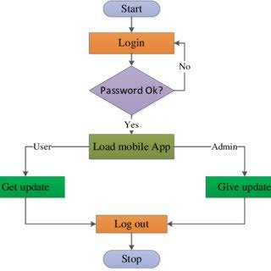

### Module Description

**Event Listing and Filtering:**

* + Users can browse a curated list of upcoming local events categorized by type (music, art, food, sports, etc.).
  + Advanced search options to filter events by location, date, time, interests, price range, and accessibility.
  + Ability to view detailed event information including descriptions, schedules, venue details, contact information, and links to ticketing platforms.
* **Geolocation-Based Discovery:**
  + Utilize device GPS to automatically display nearby events on a map interface.
  + Customizable radius settings to control how far away events are shown.
  + Push notifications to alert users about upcoming events in their vicinity.
* **Event Creation and Management (for Organizers):**
  + User-friendly dashboard for event organizers to create and manage event listings.
  + Upload event images, set ticket pricing, manage RSVPs, and track attendee data.
  + Option to share events on social media platforms directly from the app.
* **Calendar Integration:**
  + Ability to sync discovered events with users' personal calendars (Google Calendar, Apple Calendar).
  + Reminders and notifications to alert users about approaching events.
* **Community Features:**
  + User profile creation to save favorite events and track attendance.
  + Social sharing options to recommend events to friends on the app or other social platforms.
  + Commenting and discussion forums to engage with other users regarding events.
* **Accessibility Features:**
  + Option to filter events based on accessibility needs (wheelchair accessible, ASL interpretation, etc.).
  + Large text size and color contrast customization for improved visibility.

Potential Monetization Strategies:

* **Premium Features:** Offer additional features like event analytics, targeted advertising, or priority event listings for event organizers at a subscription fee.
* **In-App Advertisements:** Integrate non-intrusive ads within the app.
* **Ticket Partnerships:** Earn commission from ticket sales by linking to external ticketing platforms.

Technical Considerations:

* **Platform Selection:** Develop for iOS, Android, or cross-platform using frameworks like React Native or Flutter.
* **Database Management:** Choose a suitable database to store event data and user information.
* **API Integration:** Utilize APIs for location services, social media sharing, and payment processing.

## IMPLEMENTATION

To implement a smartphone app for events, follow a structured development process including: defining requirements, designing the user interface, building the app functionality (including features like registration, schedule viewing, maps, and push notifications), thorough testing, deployment to app stores, and ongoing maintenance based on user feedback; key considerations include choosing the right technology stack, ensuring seamless integration with event management systems, and prioritizing user experience for a smooth event navigation experience.

Key Steps in Event App Development:

1. Planning and Analysis:

* **Define goals and target audience:**Clearly identify the event's purpose, who the attendees will be, and what features would be most valuable to them.
* **Competitor analysis:**Research existing event apps to identify best practices and potential gaps in the market.
* **Feature list:**Create a detailed list of desired functionalities, including registration, schedule viewing, speaker information, venue maps, networking tools, live polls, and push notifications.
* **Technology selection:**
* appropriate development platforms
* (iOS,Android, or cross-platform) and backend
* technologies based on your needs.

2. Design and Prototyping:

* **Wireframing:** Create basic layouts to visualize the app's navigation flow and user interaction.
* **UI/UX design:** Develop a visually appealing and intuitive interface that aligns with brand identity.
* **Prototyping:** Build interactive prototypes to test user flow and gather feedback.

3. Development and Implementation:

* **Backend development:**Build the server-side infrastructure to manage data storage, user authentication, and API endpoints.
* **Frontend development:**Implement the app's visual elements and user interactions according to the design.
* **Feature integration:**Add core features like:
  + **Registration and ticketing:** Secure ticket purchase and registration process
  + **Schedule management:** Display event schedule with session details, speaker profiles, and location information
  + **Venue maps:** Interactive venue maps with wayfinding capabilities
  + **Push notifications:** Real-time updates on schedule changes, important announcements, and reminders
  + **Networking tools:** Facilitating attendee connections through messaging or profile viewing

4. Testing and Quality Assurance:

* **Functional testing:** Verify that all app features work as intended across different devices and operating systems.
* **Usability testing:** Gather feedback from real users to identify areas for improvement in user experience
* **Performance testing:** Assess app responsiveness and loading times under various conditions

5. Deployment and Launch:

* **App store submission:** Prepare and submit the app to the relevant app stores (Apple App Store and Google Play Store).
* **Marketing and promotion:** Communicate the app's availability to attendees through various channels.

6. Maintenance and Updates:

* **Bug fixes:** Address any issues reported by users
* **Feature enhancements:** Add new functionalities based on user feedback and event requirements
* **Security updates:** Implement security patches to protect user data

Important Considerations:

* **Data security:**Prioritize robust data encryption and privacy measures to protect user information.
* **Offline functionality:**Consider features that work even when there is limited internet connectivity.
* **Accessibility:**Design the app to be accessible to users with disabilities.
* **Scalability:**Choose a technology stack that can accommodate future growth and evolving event needs.

**Coding:**

## HTML CODE

<!DOCTYPE html>

<html lang="en">

<head>

<meta charset="UTF-8">

<meta name="viewport" content="width=device-width, initial-scale=1.0">

<title>Event Management App</title>

<link rel="stylesheet" href="styles.css">

</head>

<body>

<div class="app-container">

<h1>Event Management</h1>

<div class="event-form">

<h2>Add an Event</h2>

<label for="event-name">Event Name:</label>

<input type="text" id="event-name" placeholder="Enter event name" required><br>

<label for="event-date">Event Date:</label>

<input type="date" id="event-date" required><br>

<button onclick="addEvent()">Add Event</button>

</div>

<h2>Upcoming Events</h2>

<ul id="event-list">

<!-- Event list items will appear here -->

</ul>

</div>

<script src="script.js"></script>

</body>

</html>

CSS CODE

* {

margin: 0;

padding: 0;

box-sizing: border-box;

}

body {

font-family: Arial, sans-serif;

background-color: #f4f4f9;

padding: 20px;

}

.app-container {

max-width: 600px;

margin: 0 auto;

background-color: white;

padding: 20px;

border-radius: 8px;

box-shadow: 0 4px 8px rgba(0, 0, 0, 0.1);

}

h1, h2 {

text-align: center;

margin-bottom: 20px;

}

.event-form {

margin-bottom: 20px;

}

input[type="text"], input[type="date"] {

width: 100%;

padding: 10px;

margin: 10px 0;

border: 1px solid #ddd;

border-radius: 4px;

}

button {

width: 100%;

padding: 10px;

background-color: #4CAF50;

color: white;

border: none;

border-radius: 4px;

font-size: 16px;

cursor: pointer;

}

button:hover {

background-color: #45a049;

}

ul {

list-style: none;

}

li {

background-color: #f9f9f9;

padding: 10px;

margin-bottom: 10px;

border-radius: 4px;

box-shadow: 0 1px 3px rgba(0, 0, 0, 0.1);

}

li span {

font-weight: bold;

}

JAVA SCRIPT CODE

// Array to store event data

let events = [];

function addEvent() {

const eventName = document.getElementById("event-name").value;

const eventDate = document.getElementById("event-date").value;

if (!eventName || !eventDate) {

alert("Please fill in both fields.");

return;

}

const newEvent = { name: eventName, date: eventDate };

events.push(newEvent);

displayEvents();

// Clear form fields after submission

document.getElementById("event-name").value = "";

document.getElementById("event-date").value = "";

}

function displayEvents() {

const eventList = document.getElementById("event-list");

eventList.innerHTML = ""; // Clear the list before adding

events.forEach(event => {

const li = document.createElement("li");

li.innerHTML = `<span>${event.name}</span> - ${new Date(event.date).toLocaleDateString()}`;

eventList.appendChild(li);

OUTPUT

When you load this code in a browser, you should see a page with a simple form that lets you input the name and date of an event. When you click the "Add Event" button, the event will be added to a list below the form, displaying the event name and date in a formatted way.

This is a basic, static example that can be extended further by adding features such as:

* Event deletion
* Event editing
* Persistent storage (using localStorage or connecting to a backend)
* Date sorting

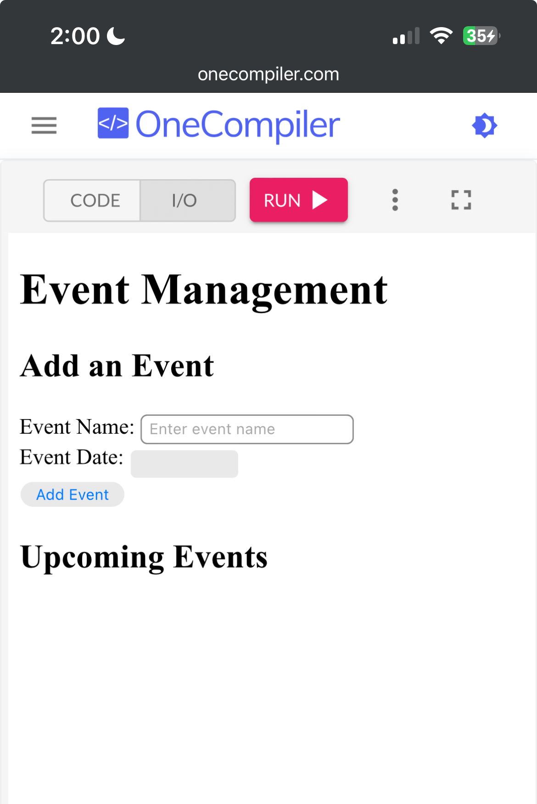

## CONCLUSION

Smartphone apps are a crucial part of modern society, and they have many benefits for both individuals and organizations:

* **Accessibility**: Apps make it easy to access information and services on-the-go.
* **Communication**: Apps can make it easier to communicate with others, and in emergencies, they can provide alerts to users' locations.
* **Productivity**: Apps can boost productivity and streamline workflows.
* **Competitive advantage**: Apps can help businesses improve customer experiences, increase operational efficiency, and maintain a competitive edge.

However, the rise of mobile apps has also raised concerns about privacy and security. Apps often collect and share personal data without users' knowledge or consent. Users should be mindful of these risks and take steps to protect their privacy.

Here are some other things to consider about smartphone apps:

* **App development**Mobile app development and marketing are both important for the success of an app.
* **App guidelines**Apps can be banned or removed from app stores if they don't follow the guidelines of their target platform.
* **Cross-platform apps**Cross-platform apps can run on multiple platforms, such as Android and iOS, after being coded once.

References

1.<https://www.researchgate.net/publication/262528189_Event-Based_Mobile_Social_Networks_Services_Technologies_and_Applications>

2.<https://developers.facebook.com/docs/app-events/reference/>

3.<https://www.researchgate.net/publication/37684711_Event_Management_for_Mobile_Users>

4.<https://scholarworks.lib.csusb.edu/cgi/viewcontent.cgi?article=1851&context=etd>

THANK YOU!